Ezema, Chukwuebuka

University of South Florida

EXAM 1 C.EZEMA

Advance Database

Table of Contents

Create Table Design using 5th and 6th Normal forms. 2

Create Database 3

Data Dictionary of labels, data types, constraints for Table Design. 3

Database diagram for each schema with PK/FK Relationships. 4

Checks and Defaults 4

Rules 5

Triggers 6

Trigger 2 6

Views and SPROCs using Joins and Aggregators 7

USER STORIES 8

Left Join 8

Logic Check: 8

Full Join 9

Logic Check: 9

Right Join 10

Logic Check 10

# Create Table Design using 5th and 6th Normal forms.

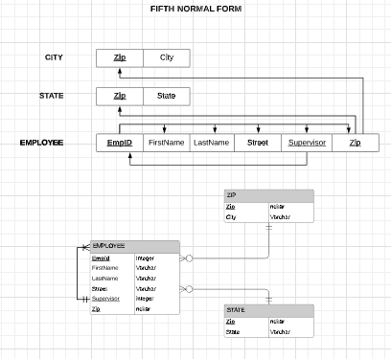

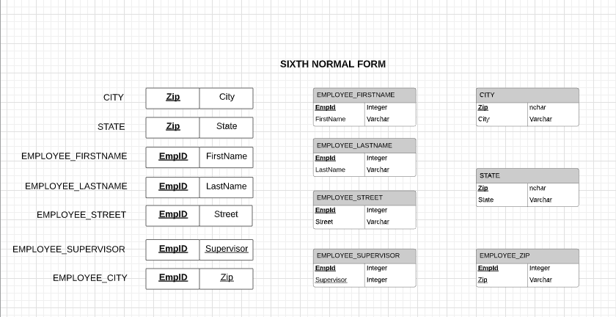

## Create Database

## Data Dictionary of labels, data types, constraints for Table Design.

C_EZEMA_EXAM1 – DATA DICTIONARY

Table: **HR.Employee**

|  |  |  |  |  |  |  |  |  |  |
| --- | --- | --- | --- | --- | --- | --- | --- | --- | --- |
| **Column Name** | **Description** | **Data Type** | **Size** | **Identity** | **Unique** | **Default** | **Check** | **Allow Nulls** | **Index** |
| EmpID | **PK**; Unique Employee ID | varchar | 10 |  |  |  |  |  | Y |
| FirstName | Employee First Name | varchar | 40 |  |  |  |  |  |  |
| LastName | Employee Last Name | varchar | 40 |  |  |  |  |  |  |
| DOB | Employee DOB | date |  |  |  |  | >= '1963-01-01' |  |  |
| PhoneNumber | Employee Phone # | varchar | 13 |  |  |  |  |  |  |
| Salary | Employee Salary | Money |  |  |  |  |  |  |  |
| Email | Personal E-mail | varchar | 255 |  |  |  |  |  |  |
| Zip | Field zip | nchar | 5 |  |  | 33620 | LIKE '[0-9][0-9] [0-9][0-9][0-9]' |  |  |

Table: **Prod.Product**

|  |  |  |  |  |  |  |  |  |  |
| --- | --- | --- | --- | --- | --- | --- | --- | --- | --- |
| **Column Name** | **Description** | **Data Type** | **Size** | **Identity** | **Unique** | **Default** | **Check** | **Allow Nulls** | **Index** |
| PID | **PK**; Unique Product ID | smallint |  |  |  |  |  |  | Y |
| Name | Product Name | varchar | 14 |  |  |  |  |  |  |
| Type | Product Type | varchar | 14 |  |  | ‘Website’ |  |  |  |
| Price | Product Price | money |  |  |  |  |  |  |  |

Table: **Aud.EmployeeSalary_Audit**

|  |  |  |  |  |  |  |  |  |  |
| --- | --- | --- | --- | --- | --- | --- | --- | --- | --- |
| **Column Name** | **Description** | **Data Type** | **Size** | **Identity** | **Unique** | **Default** | **Check** | **Allow Nulls** | **Index** |
| AuditID | **PK**; Unique Audit ID | smallint |  |  |  |  |  |  | Y |
| EmpFName | Employee First Name | varchar | 40 |  |  |  |  |  |  |
| EmpLName | Employee Last Name | varchar | 40 |  |  |  |  |  |  |
| Operation | Employee DOB | varchar | 3 |  |  |  |  |  |  |
| ModifiedDate | Employee Phone # | date |  |  |  |  |  |  |  |
| Salary | Employee Salary | money |  |  |  |  |  |  |  |

Table: **dbo.Employee_Product**

|  |  |  |  |  |  |  |  |  |  |
| --- | --- | --- | --- | --- | --- | --- | --- | --- | --- |
| **Column Name** | **Description** | **Data Type** | **Size** | **Identity** | **Unique** | **Default** | **Check** | **Allow Nulls** | **Index** |
| EmpID | **FK**; Employee ID | varchar | 10 |  |  |  |  |  |  |
| ProdID | **FK**; Product ID | smallint |  |  |  |  |  |  |  |
| Quantity | Product Type | smallint |  |  |  |  |  |  |  |

## Database diagram for each schema with PK/FK Relationships.

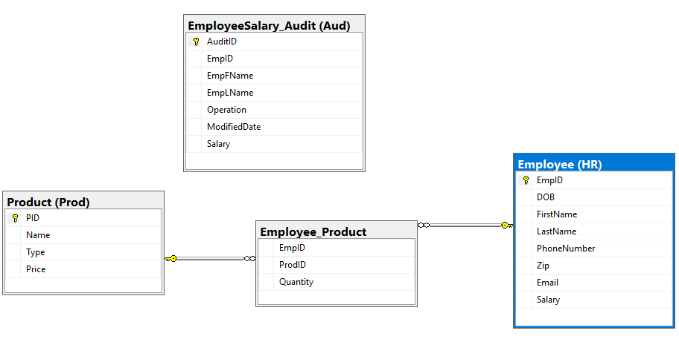

## Checks and Defaults

## Rules

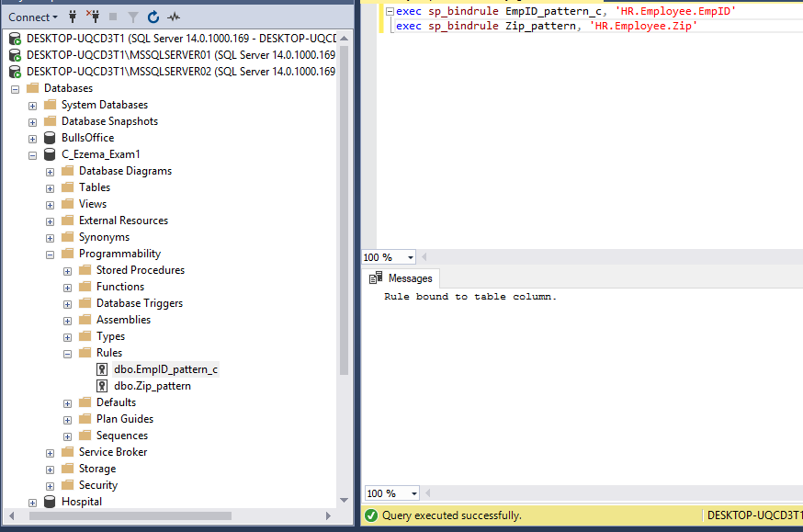

## Triggers

### Trigger 2

# Views and SPROCs using Joins and Aggregators

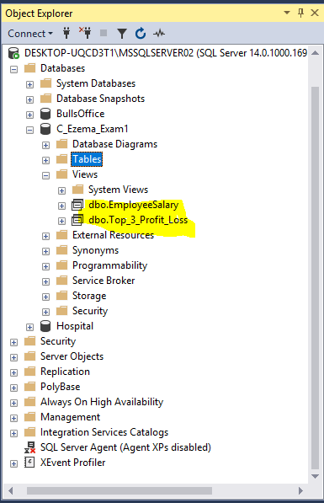 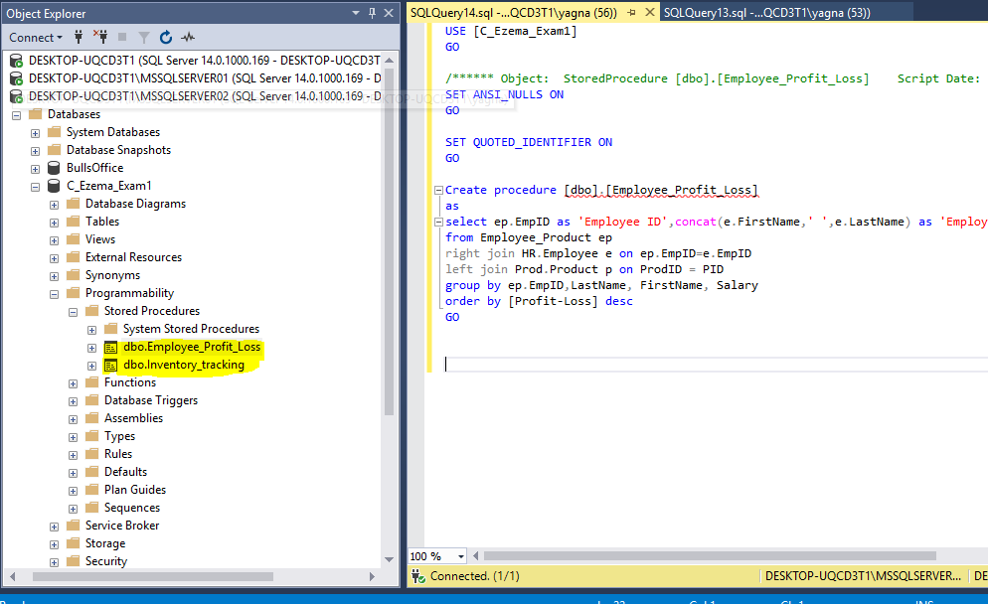

# USER STORIES

### Left Join

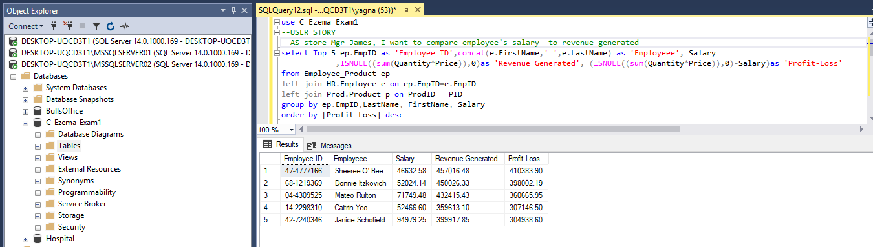As the store Manager James, I want to know my Top 5 employees so that they are recognized.

### Logic Check:

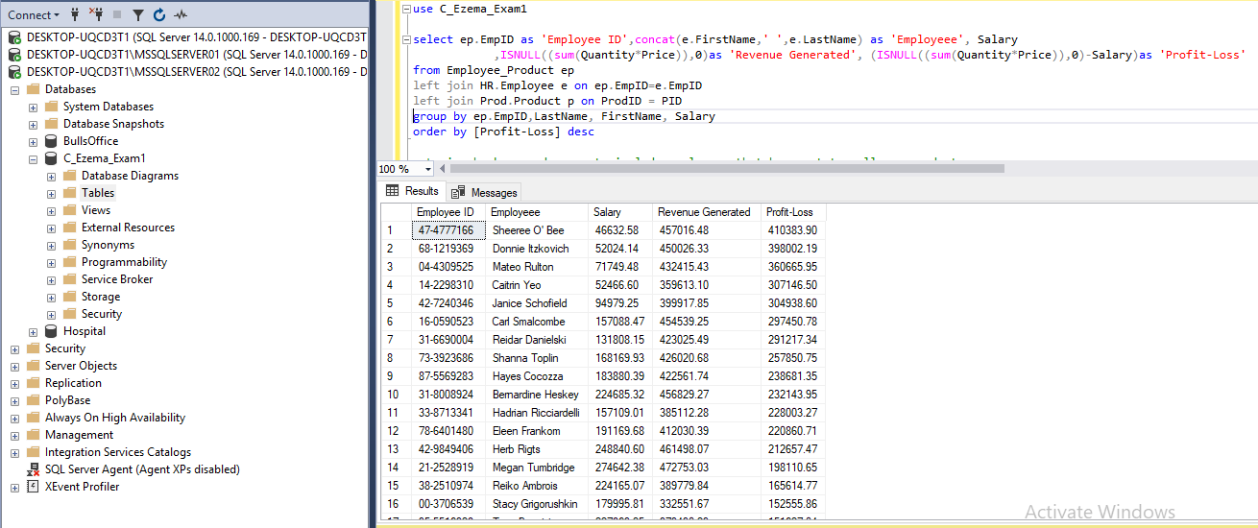Expanded the query results from showing only top 5 to showing profit-Loss for all employees

### Full Join

As the sales manager Joan, I want to see all employees that have yet to sell any product so that they can be re-trained

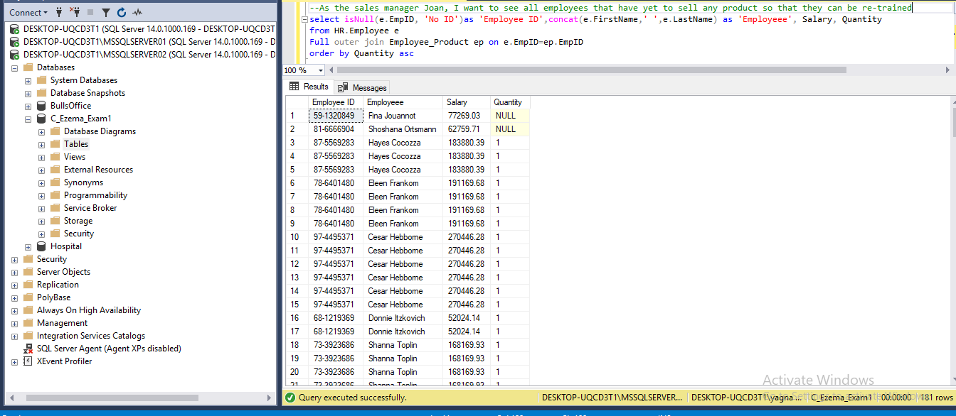

### Logic Check:

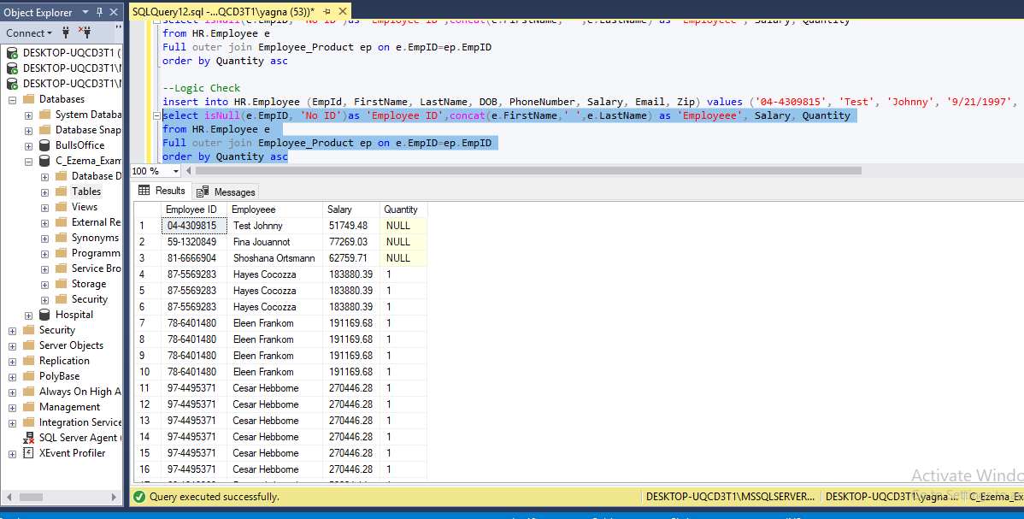Added a new user Johnny Test to see if he would be populated when query was refreshed

### Right Join

As store owner Jackie, I want to know the average earnings of each my top 3 sales rep so that they can used for benchmarking

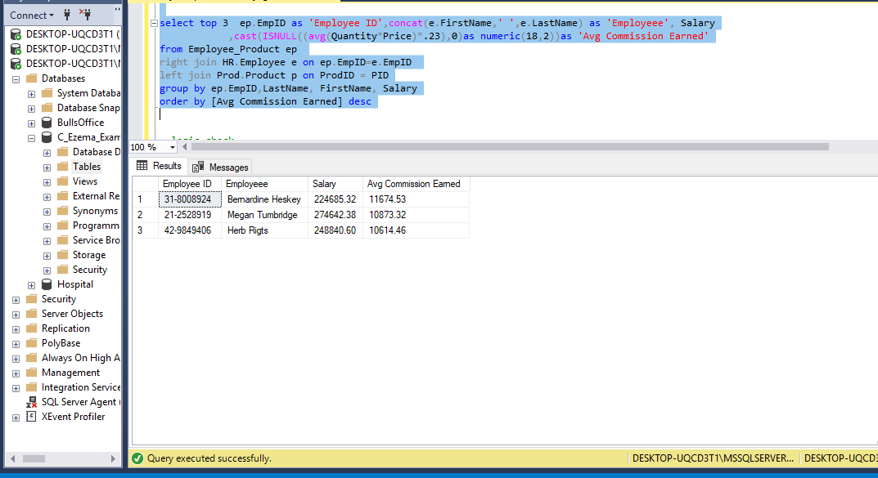

Logic Check :

Expanding from top 3 to see the avg earnings of all employees

